Supplementary material to

Adapting HPVsim to model HPV transmission, cervical cancer diagnoses and different public health interventions in high-income countries: modelling study for England

Fabian Sturman^{1,2*}, Sophie Keenan³, Kate Soldan⁴, Robyn Stuart⁵, Katrina Lythgoe^{1,2,6},
Jasmina Panovska-Griffiths^{1,2,4,7*}

[1] The Pandemic Sciences Institute, University of Oxford, Oxford, UK
[2] Big Data Institute, University of Oxford, Oxford, UK
[3] Mathematical Institute, University of Oxford, Oxford, UK
[4] UK Health Security Agency, London UK
[5] Institute for Disease Modeling, Gates Foundation, USA
[6] Department of Biology, University of Oxford, Oxford, UK
[7] The Queen's College, University of Oxford, Oxford, UK
*Corresponding authors: fabian.sturman@oriel.ox.ac.uk, jasmina.panovska-griffiths@queens.ox.ac.uk

S0: Introduction
This document is supplementary to our paper “Adapting HPVsim to model HPV transmission, cervical cancer diagnoses and different public health interventions in high-income countries: modelling study for England” [1], which should be read in advance of the following text. In the paper’s main body, we apply HPVsim, an Agent Based Model (ABM) of Human Papillomavirus (HPV) and cervical cancer transmission and dynamics, to the English setting for the first time, and apply the model to an analysis of the likelihood of achieving cervical cancer elimination by 2040 in England.

In this document, we provide (1) an enumeration of model parameters of HPV prevalence and intervention characteristics changed from the default HPVsim model [2], (2) our results from calibration to (and validation against) English cervical cancer data, (3) validation against English HPV prevalence data for teens and young adults.

All code is open source and available at our project GitHub, [3].

S1: Non-Calibrated Model Parameters
Table 1 presents initial (seeded) HPV prevalence in our model by age bracket. Data for women is informed by WHO data for England ( [4], Figure 54). Data for men is informed by USA estimates ( [5], Figure 2). At the beginning of each simulation (year 1980), agents are randomly assigned HPV prevalence according to Bernoulli variables parameterised as in Table 1 according to their sex and age, with their HPV genotype randomly selected as in [4]. A 20-year burnin (with simulation generation time 3 months) allows for infection to spread over the population in a naturalistic way, which we validate later through downstream cancers (S2) and directly in terms of HPV infection prevalence (S3).

Initial HPV Prevalence by Sex and Age Group, over all Genotypes
Age (years) | 0-16 | 17-24 | 25-34 | 35-44 | 45-54 | 55-64 | 65+
Initial Female HPV Prevalence | 0 | 0.25 | 0.14 | 0.08 | 0.06 | 0.06 | 0.03
Initial Male HPV Prevalence | 0 | 0.20 | 0.23 | 0.20 | 0.18 | 0.25 | 0.25
Table 1: Assumed Initial HPV Prevalence by Sex and Age Group, over any genotype. This defines how HPV is seeded over out model, before a 20-year burnin period to smooth towards realistic dynamics.

We inform test and intervention characteristics by meta-analyses within England, or comparable high-income settings when data specifically from England is unavailable. HPV DNA test characteristics (Table 2) are informed by the meta analyses of Mustafa et al [6], Cytology characteristics (Table 3) by that of Koliopoulos et al. [7].

Model of HPV DNA test characteristics.
Agent State | Outcome Distribution
Agent State | Positive | Negative
Susceptible | 0.12 | 0.88
Latent | 0.12 | 0.88
Precin | 0.94 | 0.06
CIN | 0.94 | 0.06
Cancerous | 0.94 | 0.06

Table 2: Modelled HPV DNA test characteristics defined in terms of probability of testing positive/negative for HPV as a Bernoulli variable when conditioned on agent infection state.

Model of Cytology characteristics.
Agent State | Outcome Distribution
Agent State | Normal | Abnormal
Susceptible | 0.96 | 0.04
Latent | 0.96 | 0.04
Precin | 0.96 | 0.04
CIN | 0.3 | 0.7
Cancerous | 0 | 1

Table 3: Modelled Liquid-Based Cytology (LBC) characteristics, as a Benoulli variable conditioned on agent cellular state.

Mustafa et al. find colposcopy sensitivity at 0.95 and specificity at 0.42 [6]. Our modelling only acts on three outcomes from colposcopies - 'hsil' (prompting ablation) or 'cancer' (prompting general cancer treatment), or 'normal' (prompting no treatment). Our modelled colposcopy characteristics (Table 4) are informed by these reported sensitivities and specificities, and additionally agree with the work of Brown and Tidy ( [8]; using their second definition of colposcopy outcomes).

Model of Colposcopy characteristics.
Agent State | Outcome Distribution
Agent State | Normal | Abnormal: HSIL | Abnormal: Cancer
Susceptible | 0.7 | 0.3 | 0
Latent | 0.6 | 0.4 | 0
Precin | 0.42 | 0.58 | 0
CIN | 0.05 | 0.95 | 0
Cancerous | 0 | 0.05 | 0.95
Table 4: Modelled Colposcopy characteristics, as a Bernoulli variable conditioned on agent cellular state. Two abnormal outcomes are modelled to distinctly represent diagnosis of pre-cancer and of cancer.

S2: Calibration Results
The parameter samples and associated Goodness of Fit (GOF) values arising from calibration are available on the project GitHub [3].

Below, we report goodness of fit to seen and unseen cervical cancer incidence data, and to seen cervical cancer genotype distribution data. This is following 13-parameter calibration over three repeat trials, extraction of the 45 parameter samples with the best GOF, and elimination of parameter samples which are too close in parameter-space to leave 44 calibrated parameter-sets (as in Methods, [1]).

Observed cervical cancer incidence data is from NHS registration statistics [9] for years 2012-2018, with data from 2018-2022 from the analysis of Gilham and Peto [10]. HPV genotype distribution of individuals with cervical cancer is taken from the analysis of Mesher et al. [11].

We observe visually close fits to both seen (Figure 1) and unseen (Figure 3) data, with both median and upper-quartile GOF under 0.2 for seen (Figure 2) and unseen (Figure 4) data. This indicates a close fit which does not deteriorate under short-term extrapolation of data, validating our model in terms of cervical cancer output. We observe that cervical cancers are overestimated amongst individuals aged under 25 across all years 2012-2022; however this overestimation does not translate to error at older age brackets as the population ages. It therefore is likely attributable to HPV prevalence assumptions at lower ages (in particular the omission of catchup vaccination within the model) and HPV infection – cervical cancer dwell time assumptions; this is discussed in more detail in the main body of this work [1].

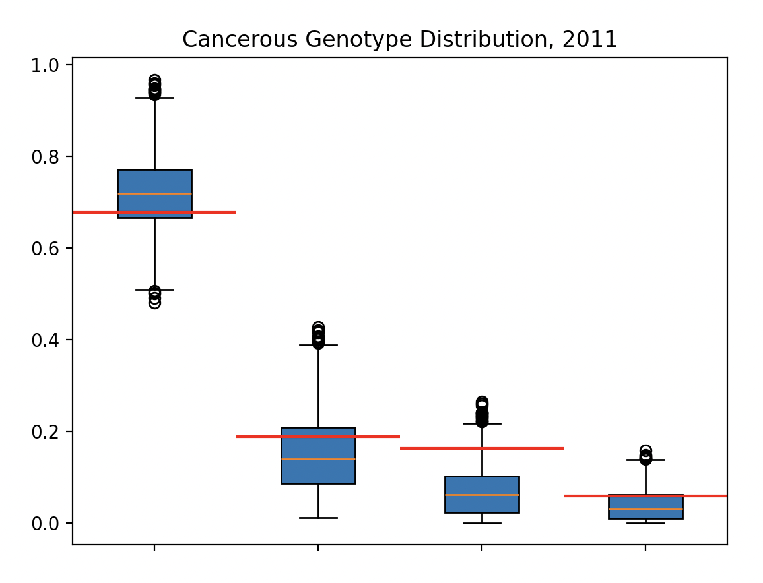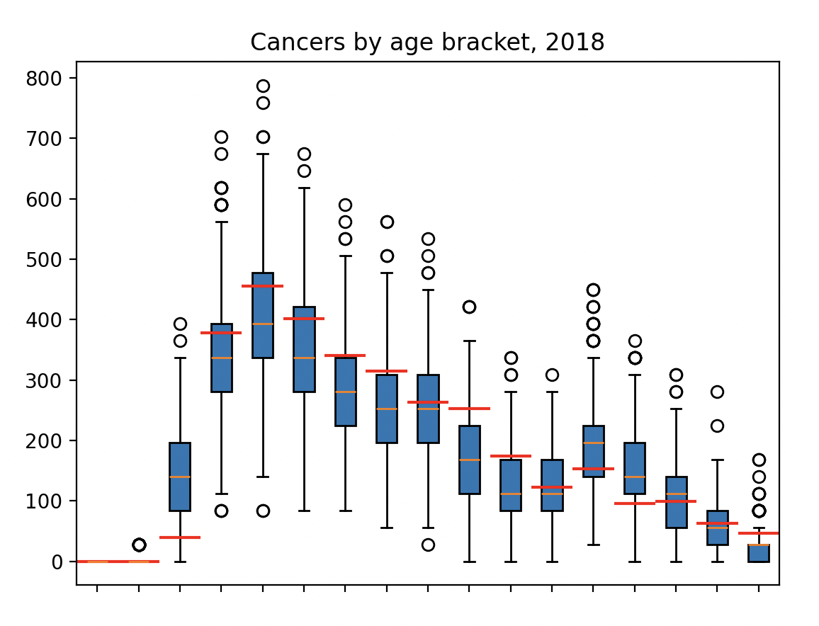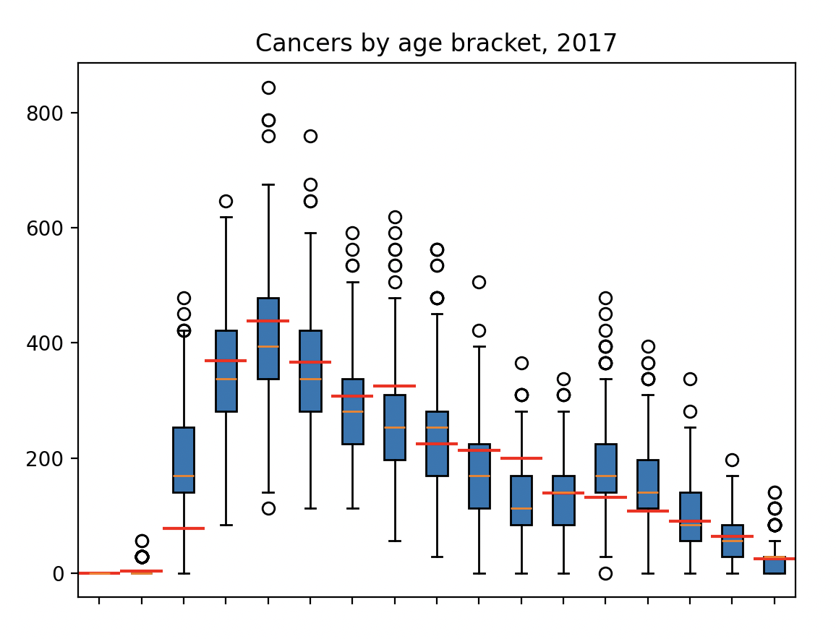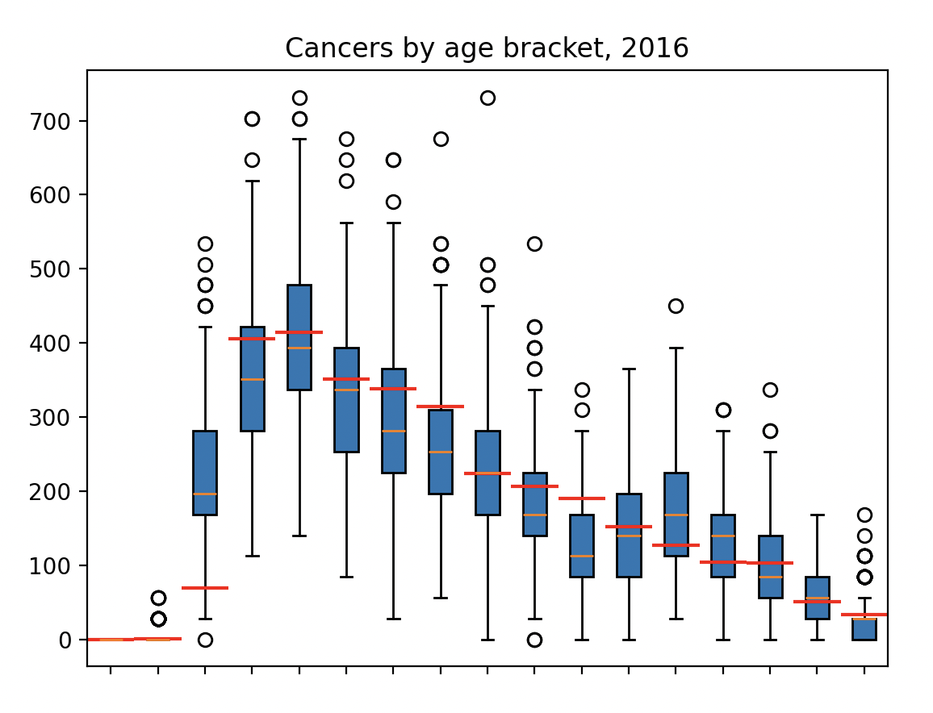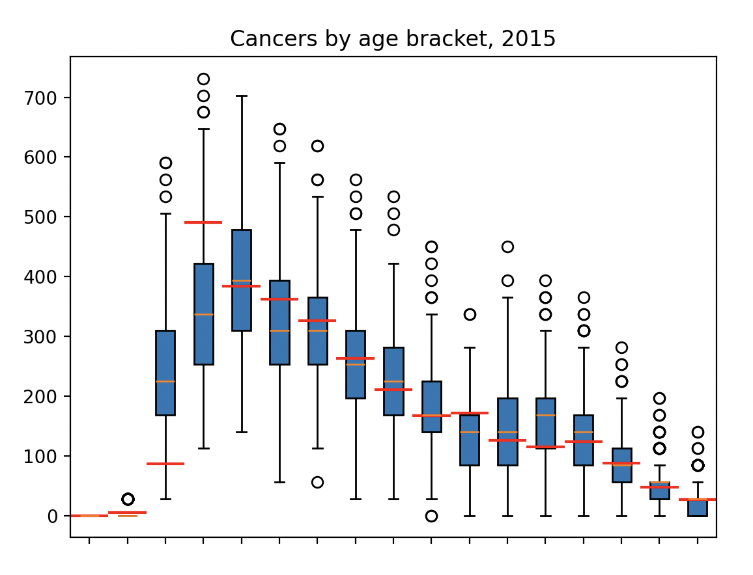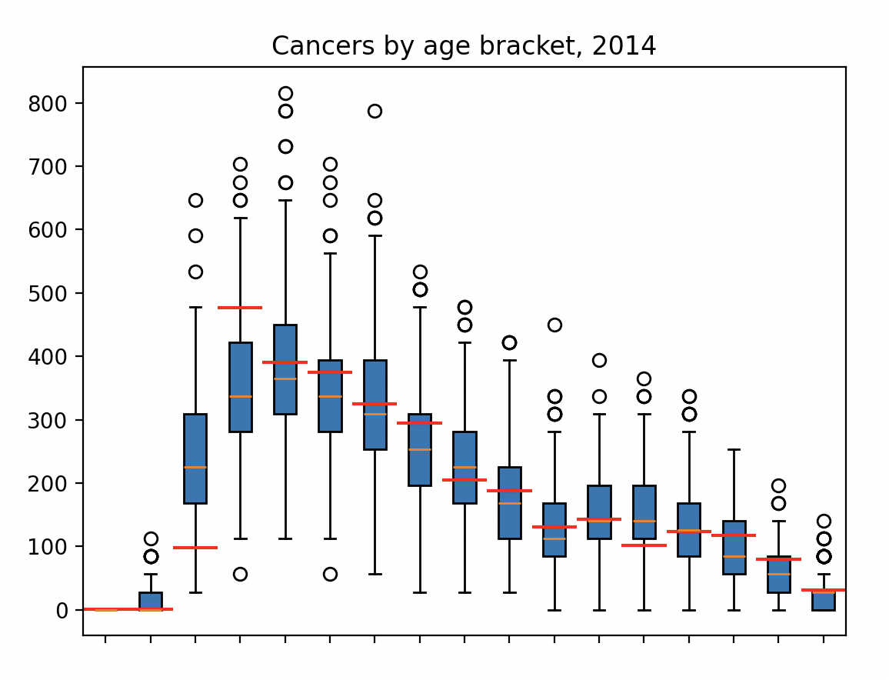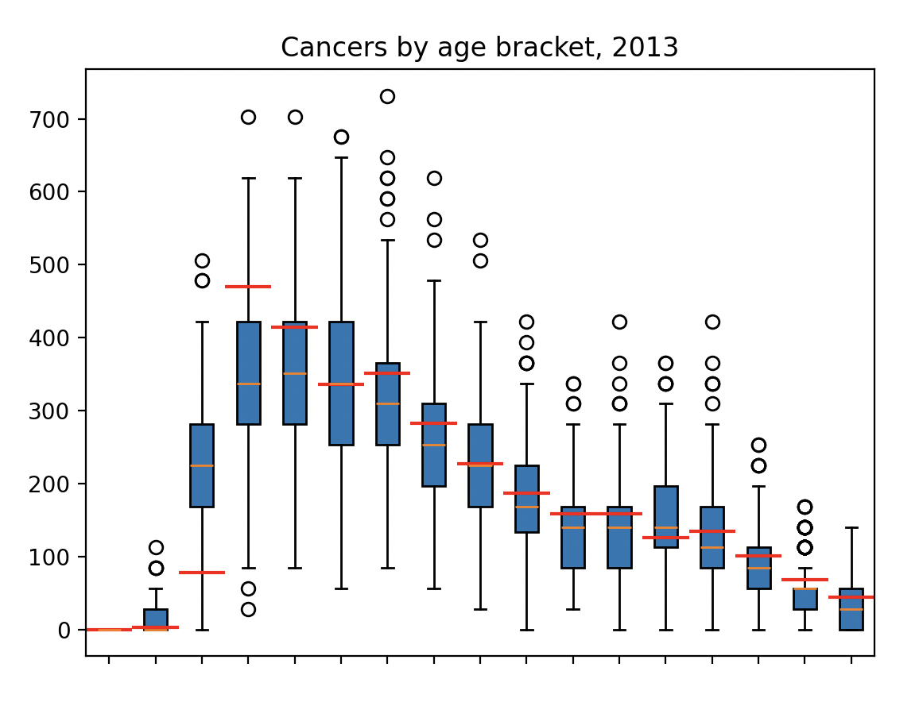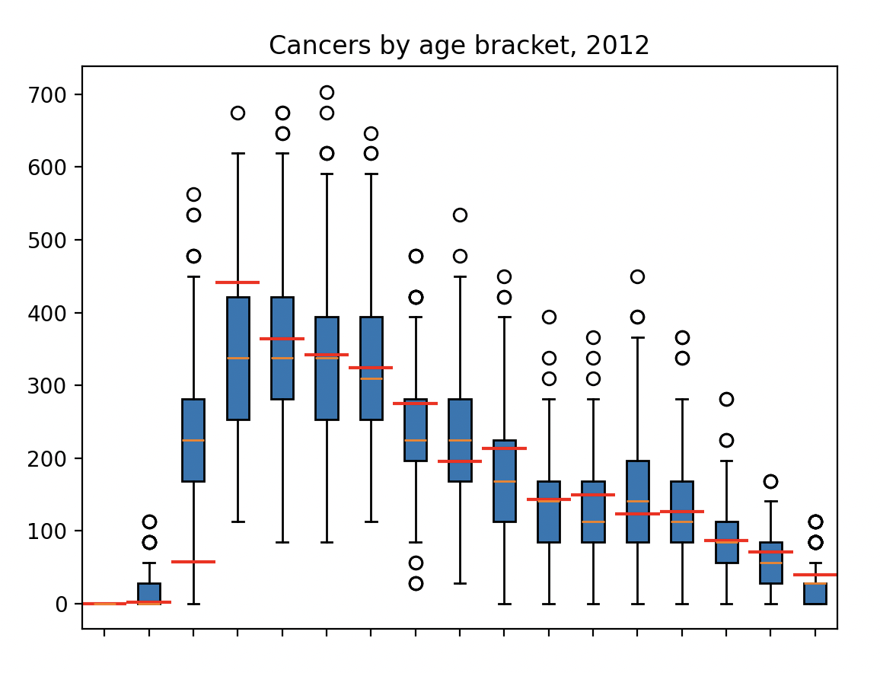
Figure 1: Fit of calibrated model against observed data (HPV genotype distribution amongst individuals with cervical cancer in 2011, and cervical cancer incidence in England by age for years 2012-2018). Stochastic model output over all 44 ensemble parameterisations are presented by box plots, with observed data by red lines. Genotypes are HPV 16, HPV 18, hi5 (HPV 31,33,45,52,58), and ohr (HPV 35,39,51,56,59), and incidence is reported in age brackets with width 5 years starting at age 15 (0-15, 16-20,21-25,26-30, … ,81-85,86+).
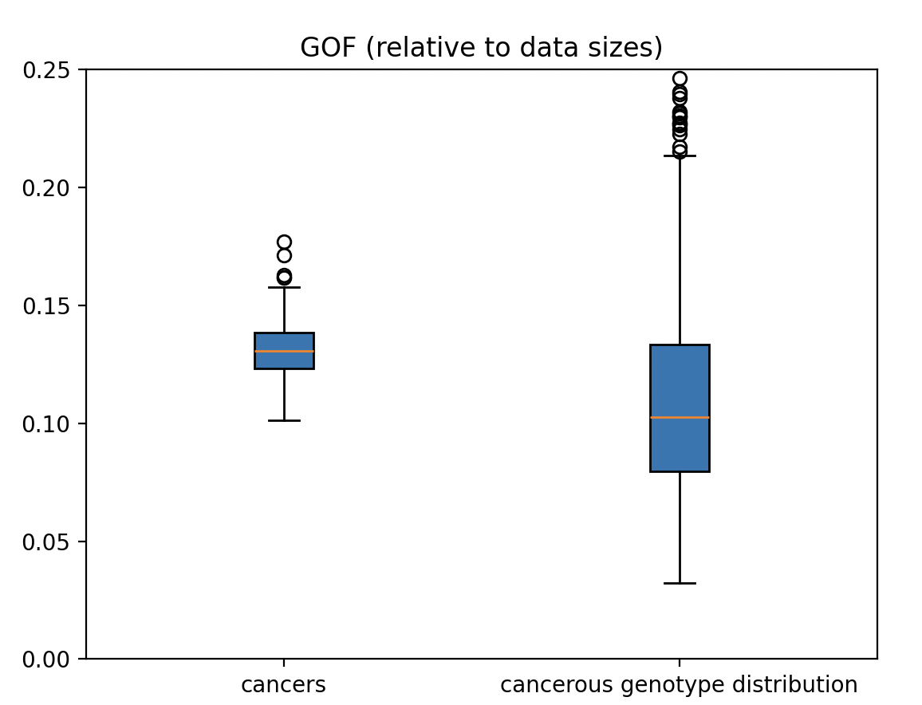
Figure 2: Model Goodness of Fit (GOF) against seen data, reported separately for fit to HPV genotype distribution of individuals with cancer, and to age-stratified cancer incidence.

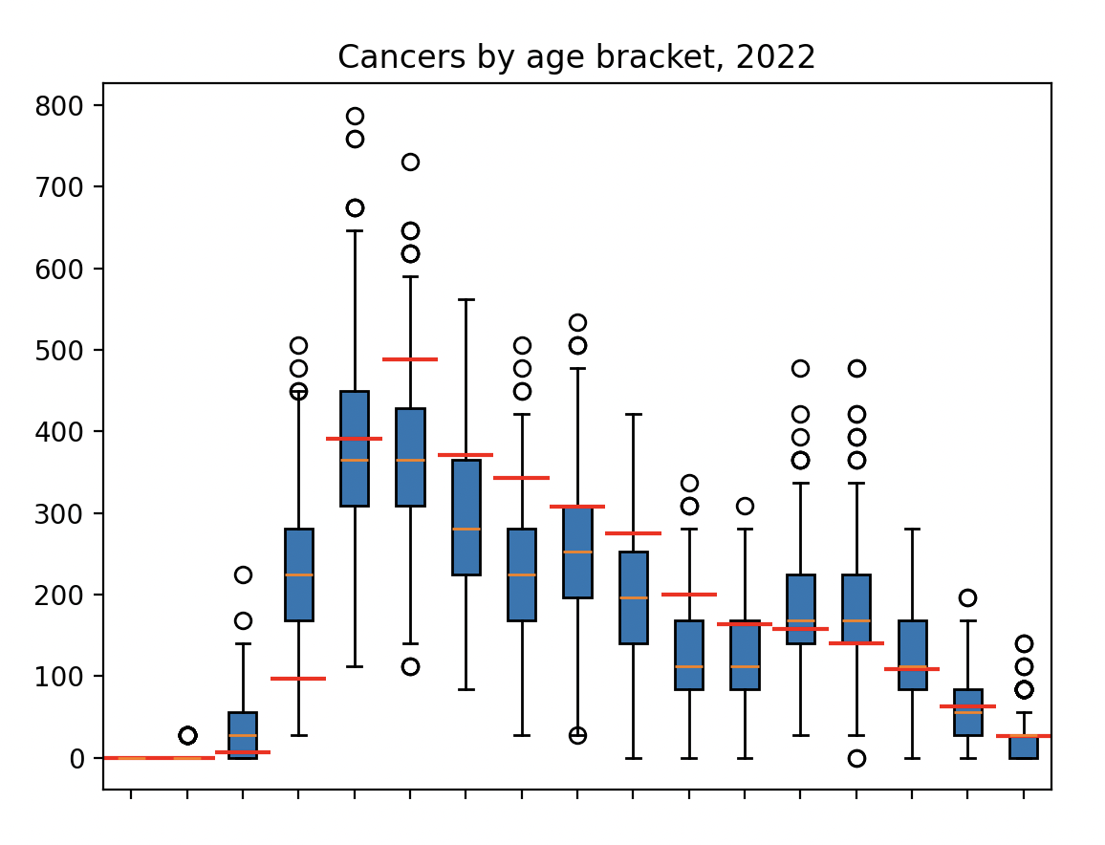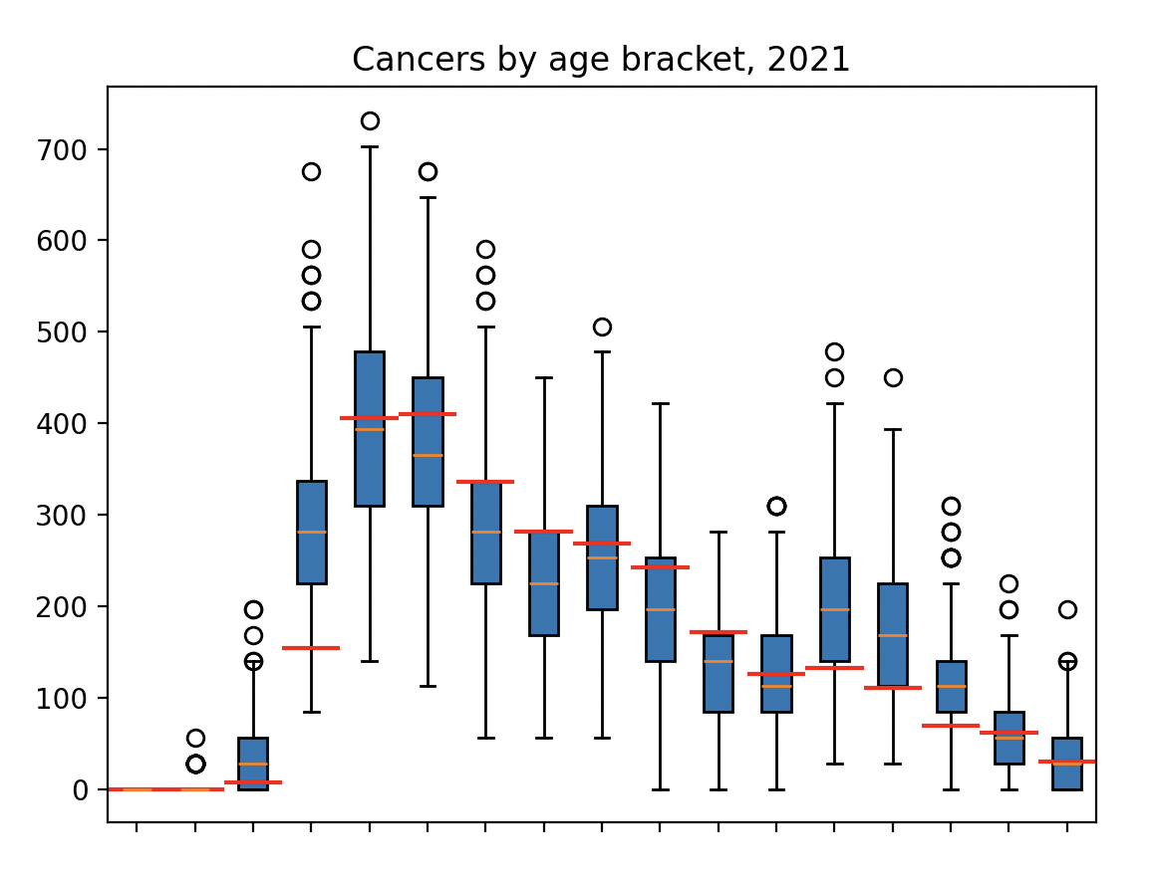
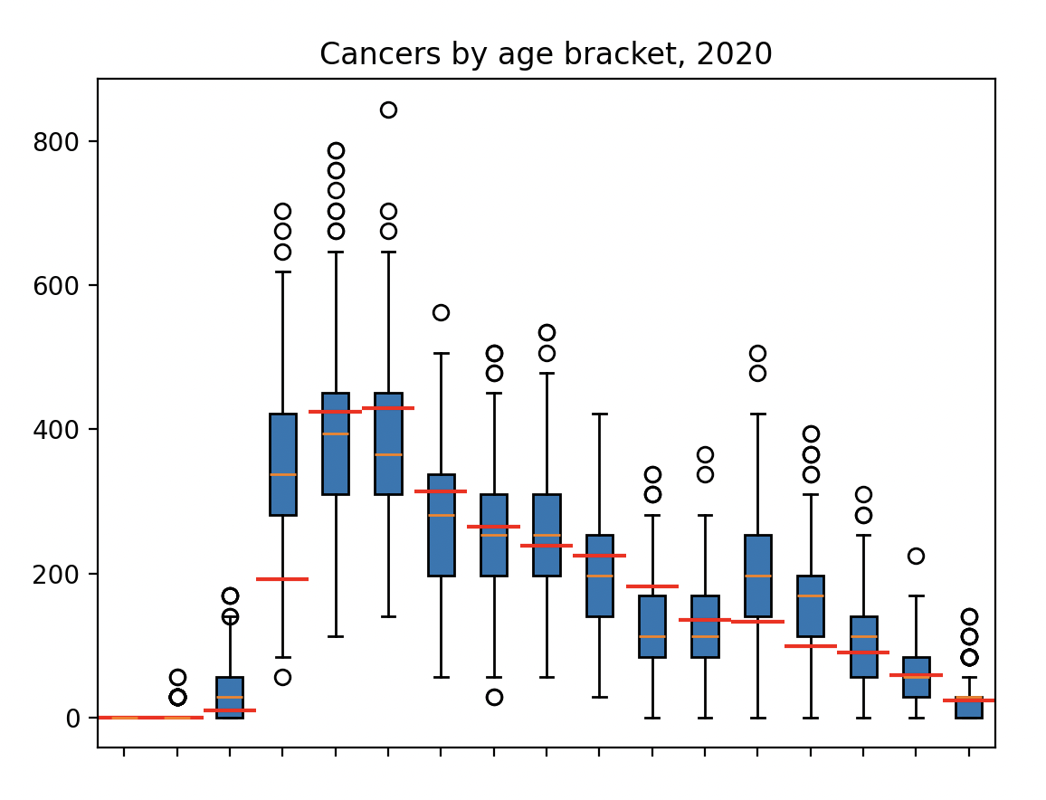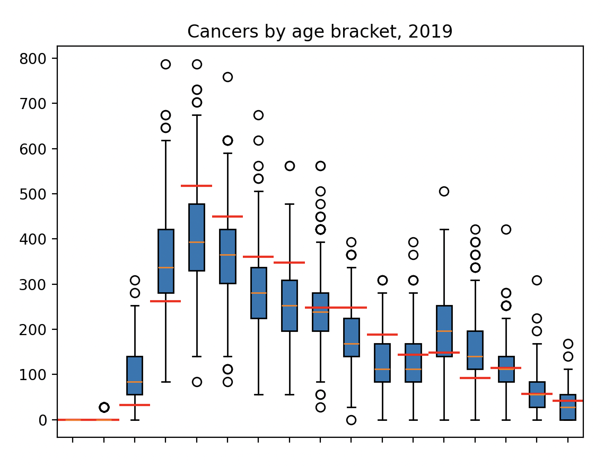
Figure 3: Fit of calibrated model against unobserved data (cervical cancer incidence in England by age for years 2019-2022). Stochastic model output over all 44 ensemble parameterisations are presented by box plots, with observed data by red lines. Genotypes are HPV 16, HPV 18, hi5 (HPV 31,33,45,52,58), and ohr (HPV 35,39,51,56,59), and incidence is reported in age brackets with width 5 years starting at age 15 (0-15, 16-20,21-25,26-30, … ,81-85,86+).

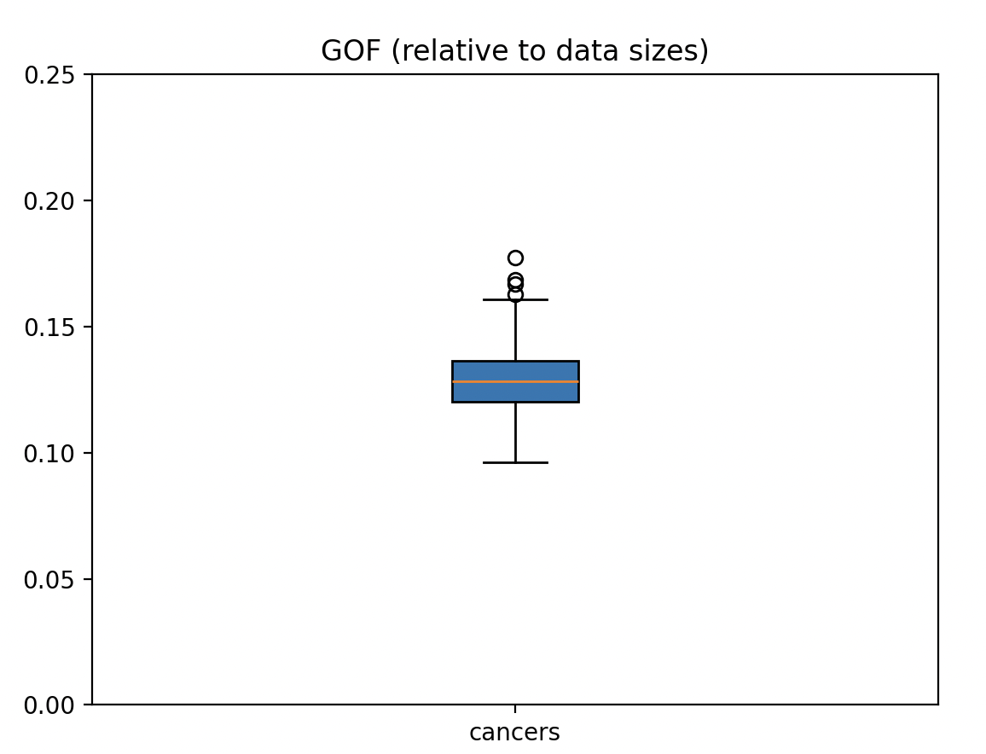
Figure 4: Model Goodness of Fit (GOF) against unseen data, reported separately for fit to HPV genotype distribution of individuals with cancer, and to age-stratified cancer incidence.

S3: HPV Prevalence
We validate our model in terms of HPV 16/18 prevalence amongst 16-18, 19-21, and 22-24 year-olds against surveillance data published by the UKHSA [12], for years 2011-2020.

We observe a good fit for 16-18 year olds throughout, with a poorer fit for older age groups due to no modelling of catch-up vaccination in our model causing overestimated prevalence in these groups (Figure 5). However, beyond 2020 our model is re-aligned with HPV cases in these age groups, as at this time individuals born in 1995 who underwent routine HPV vaccination at ages 12-13 will be 25 years old. Therefore, for analyses focussed on predicting cancers amongst the population not offered vaccination at age 12-13 but offered catch-up vaccination as older teens/young adults, our model will overestimate cancers. However, we notice that the model aligns with observed surveillance data by the year 2020 and for the population offered vaccination at ages 12-13. For longer term projections, due to the temporary nature of this transitionary period, and the convergence of our model to the correct HPV prevalences by the early 2020s, the omission of catch-up screening may therefore be negligible. This aligns with our underestimation of cancers amongst young age-groups observed when evaluating our calibration (Figure 1, Figure 3), with the magnitude of this overestimation decreasing for later years (particularly in Figure 3 compared to Figure 1).
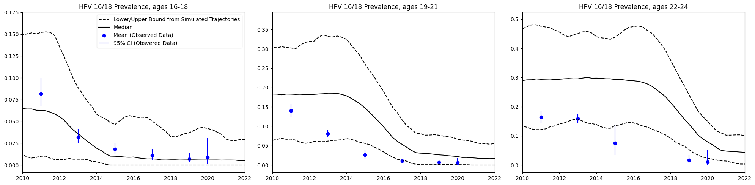
Figure 5: Modelled prevalence of HPV 16/18 between years 2010-2020 for women age 16-18, 19-21, and 22-24, defined as the fraction of women infected with either HPV 16 or HPV 18. Median (solid black curve) reported alongside lower/upper bound over simulations (dashed black curves). UKHSA reported prevalence data presented in blue with 95% uncertainty bounds.

To evaluate the effect of vaccination on HPV prevalence, we consider simulated infection prevalence by age for three annual snapshots (2010, 2030, and 2050, noting 2010 is pre-vaccination). We observe the simulated effect on HPV 16/18 prevalence of vaccine-rollout, with reduced cases over the full population in younger ages and over time (Figure 6). Modelling the prevalence of infection with hi5 HPV genotypes over the full population, we observe a similar dampening effect (Figure 7). Restricting our focus to unvaccinated individuals only, we observe a notable herd effect amongst younger, vaccine-eligible, individuals, evident from a dampening of infections amongst this cohort (Figure 8). This demonstrates the desired model effect of vaccine rollout on HPV prevalence over time.

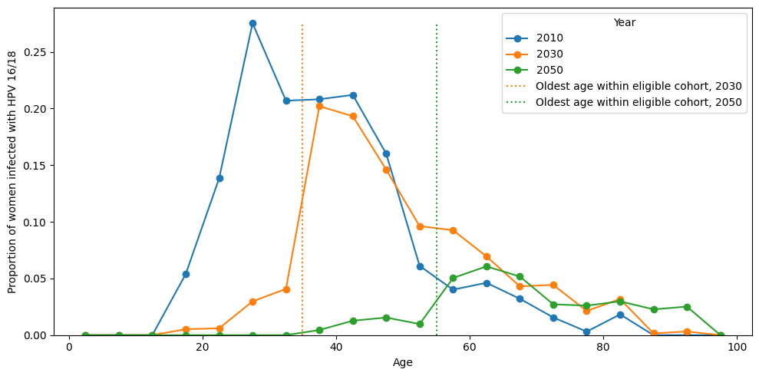
Figure 6: Modelled prevalence of infection with HPV 16/18 amongst all women, stratified by age, for three time snapshots: 2010 (pre-vaccination), 2030 (post-vaccination), and 2050 (post-vaccination). For years 2030 and 2050, dotted lines indicate the age at which the population transitions from vaccine-eligible to vaccine-ineligible.

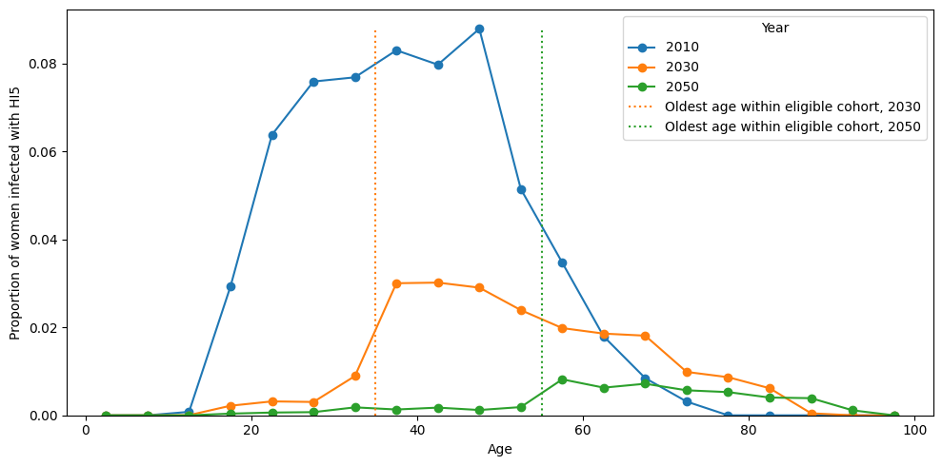
Figure 7: Modelled prevalence of infection with HPV 31/33/45/52/58 (hi5) amongst all women, stratified by age, for three time snapshots: 2010 (pre-vaccination), 2030 (post-vaccination), and 2050 (post-vaccination). For years 2030 and 2050, dotted lines indicate the age at which the population transitions from vaccine-eligible to vaccine-ineligible.

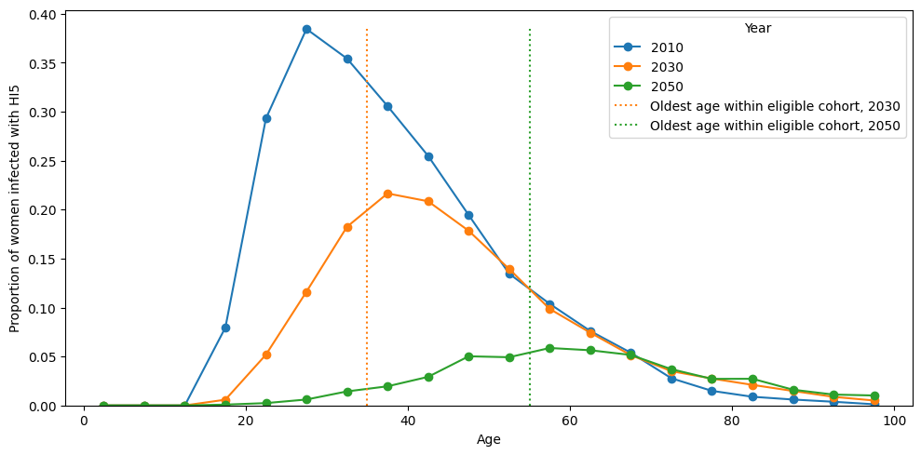
Figure 8: Modelled prevalence of infection with HPV 31/33/45/52/58 (hi5) amongst unvaccinated women, stratified by age, for three time snapshots: 2010 (pre-vaccination), 2030 (post-vaccination), and 2050 (post-vaccination). For years 2030 and 2050, dotted lines indicate the age at which the population transitions from vaccine-eligible to vaccine-ineligible.

Works Cited

[1] | F. Sturman, S. Keenan, K. Soldan, R. Stuart, K. Lythgoe and J. Panovska-Griffiths, “Adapting HPVsim to model HPV transmission, cervical cancer diagnoses and different public health interventions in high-income countries: modelling study for England,” PLoS Computational Biology, IN REVIEW, 2026.
[2] | R. Stuart, J. Cohen, C. Kerr, P. Mathur, National Disease Modelling Consortium of India, R. Abeysuriya, M. Zimmermann, D. Rao, M. Boudreau, S. Lee, L. Yang and D. Klein, “HPVsim: An agent-based model of HPV transmission and cervical disease,” PLoS Computational Biology, vol. 20, no. 7, 2024.
[3] | F. Sturman, S. Keenan, K. Soldan, R. Stuart, K. Lythgoe and J. Panovska-Griffiths, “Project Code Repository,” [Online]. Available: https://github.com/fabiansturman/HPVScreeningProject/.
[4] | H. Centre, “Human Papillomavirus and Related Diseases Report,” 10 March 2023. [Online]. Available: https://hpvcentre.net/statistics/reports/GBR.pdf?t=1667160001618.
[5] | J. Gargano, E. Unger, G. Liu, M. Steinau, E. Meites, E. Dunne and L. Markowitz, “Prevalence of Genital Human Papillomavirus in Males, United States, 2013-2014,” The Journal of Infectious Diseases, vol. 215, no. 7, pp. 1070-1079, 2017.
[6] | R. Mustafa, N. Santesso, R. Khatib, A. Mustafa, W. Wiercioch, R. Kehar, S. Gandhi, Y. Chen, A. Cheung, J. Hopkins, B. Ma, N. Lloyd, D. Wu, N. Broutet and H. Schuenemann, “Systematic reviews and meta-analyses of the accuracy of HPV tests, visual inspection with acetic acid, cytology, and colposcopy,” Int J Gynaecol Obstet., vol. 132, no. 3, pp. 259-265, 2015.
[7] | G. Koliopoulos, V. Nyaga, N. Santesso, A. Bryant, P. Martin-Hirsch, R. Mustafa, H. Schuenemann, E. Paraskevaidis and M. Arbyn, “Cytology versus HPV testing for cervical cancer screening in the general population,” Cochrane Database Syst Rev., no. 8, 2017.
[8] | B. Brown and J. Tidy, “The diagnostic accuracy of colposcopy – A review of research methodology and impact on the outcomes of quality assurance,” European Journal of Obstetrics & Gynecology and Reproductive Biology, vol. 240, pp. 182-186, 2019.
[9] | NHS England, “Cancer Registrations Statistics, England,” [Online]. Available: https://digital.nhs.uk/data-and-information/publications/statistical/cancer-registration-statistics. [Accessed 04 04 2026].
[10] | C. Gilham and J. Peto, “Is elimination of cervical cancer in sight in England?,” Preventive Medicine, vol. 191, 2025.
[11] | D. Mesher, K. Cuschieri, S. Hubbitts, J. Jamison, A. Sargent, K. Pollock, N. Powell, R. Wilson, F. McCall, A. Fiander and K. Soldan, “Type-specific HPV prevalence in invasive cervical cancer in the UK prior to national HPV immunisation programme: baseline for monitoring the effects of immunisation,” Journal of Clinical Pathology, vol. 68, no. 2, 2014.
[12] | M. Checchi, D. Mesher, K. Panwar, A. Anderson, S. Beddows and K. Soldan, “The impact of over ten years of HPV vaccination in England: Surveillance of type-specific HPV in young sexually active females,” Vaccine, vol. 41, no. 45, 2023.
[13] | F. Sturman, S. Keenan, K. Soldan, R. Stuart, K. Lythgoe and J. Panovska-Griffiths, “Adapting the frequency of cervical screening to individual HPV vaccination status: an agent-based modelling study for England,” Nature Medicine, IN REVIEW, 2026.

